**Task 1 - Full Stops and Capital Letters**

Full stops and capital letters have been taken out of this passage from ‘Percy Jackson and the Battle of the Labyrinth ‘by Rick Riordan. Can you put them back in?

|  |  |
| --- | --- |
| i didn’t feel like we were hostages or anything eurytion walked alongside us with his club across his shoulder orthus the two-headed dog growled a lot and sniffed at grover’s legs and shot into the bushes once in a while to chase animals, but eurytion kept him more or less under control  we walked down a dirt path that seemed to go on forever it must’ve been close to forty degrees, which was a shock after san francisco heat shimmered off the ground insects buzzed in the trees before we’d gone very far, I was sweating like crazy flies swarmed us every so often we’d see a pen full of red cows or even stranger animals once we passed a corral where the fence was coated in asbestos inside, a herd of fire-breathing horses milled around the hay in their feeding trough was on fire the ground smoked around their feet, but the horses seemed tame enough one big stallion looked at me and whinnied, columns of red flame billowing out of his nostrils i wondered if it hurt his sinuses  ‘what are they for?’ i asked | http://www.google.co.uk/url?source=imglanding&ct=img&q=http://thebookwormchronicles.files.wordpress.com/2011/05/percy-jackson-and-the-battle-of-the-labyrinth.jpg&sa=X&ei=Zmm_T7C9BMXk8QPVqJDCCg&ved=0CAsQ8wc&usg=AFQjCNF0uYmOKmEm3DIjL0qcVtG1K0iXRA |
| eurytion scowled. ‘we raise animals for lots of clients apollo, diomedes, and... others’  ‘like who?’  ‘no more questions’  finally we came out of the woods perched on a hill above us was a big ranch house – all white stone and wood and big windows  ‘it looks like a frank lloyd wright!’ annabeth said  i guess she was talking about some architectural things to me it just looked like the kind of place where a few demigods could get into serious trouble we hiked up the hill.  ‘don’t break the rules,’ eurytion warned as we walked up the steps to the front porch ‘no fighting no drawing weapons and don’t make any comments about the boss’s appearance’  ‘why?’ I asked ‘what does he look like? | |

How Confident are you with full stops and capital letters?

**🙂 😐 ☹️**

|  |  |
| --- | --- |
| **Mark yourself!** |  |
|  | 74 |

Task 2 – Verbs

A verb is a doing word. It tells us what is happening (present tense) or what has already happened (past tense.) Using powerful verbs makes your writing much more engaging.

[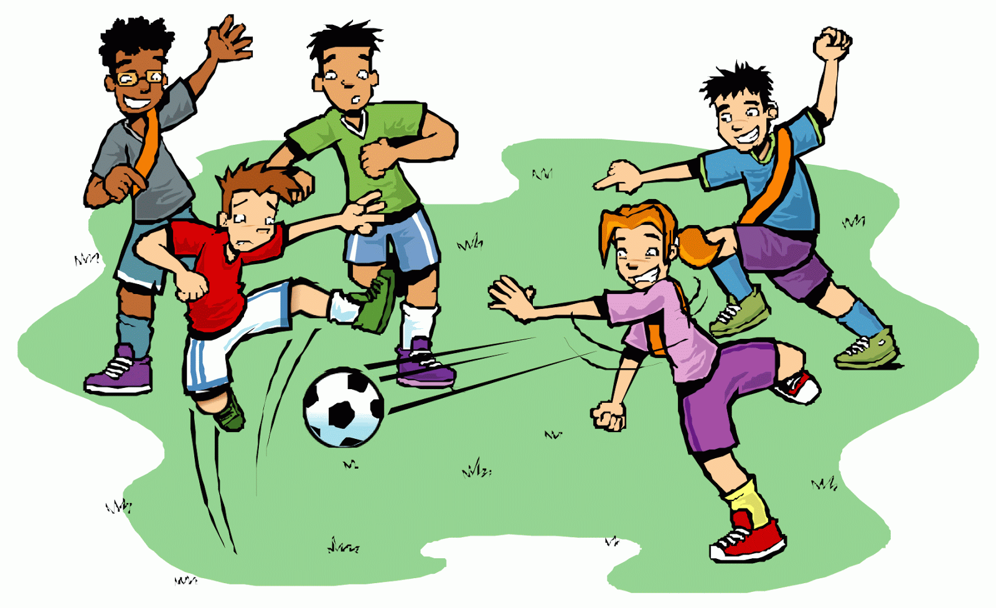](http://quoteko.com/id2/children-playing-football-clipart-gif.html)Jack kicks the ball. Jack kicked the ball.

(present tense.) (past tense.)

**Change the verbs in this story from the present tense to past tense:**

I get out of the car and step in a puddle. We hear the band playing. They have started already! I run all the way to the hall.

I get up and 8 o’clock and go down stairs to make my breakfast. Then I brush my hair and wash my teeth. I leave my house at half past eight.

Some verbs are more powerful than others. Powerful verbs are more descriptive; they give

the reader a better image. For example, we could replace the word ‘walked’, with

‘sauntered’, ‘scrambled’, or ‘shuffled’.

Now try this-

**Change the verb said to a more interesting verb each time:**

1. “The hills are alive with the sound of music.”…………………………….. Bob.

2. “Get out of my sight, you ungrateful, horrible woman.”……………………..

Ryan.

3. “I think we should be quiet; no one else is talking in here.”………………… Margaret

whispered zoomed bellowed rushed screamed

stomped shouted sang sprinted

Think of three or more power verbs to replace the words in the table. Use a thesaurus to help you.

|  |  |
| --- | --- |
| **Verb** | **Power Verb** |
| hated |  |
| liked |  |
| lied |  |
| jumped |  |
| fell |  |
| smiled |  |

Now try rewriting this passage using power verbs to create a stronger image.

She decided to jump over the fence and run across the road when she saw me. I started to

run in the other direction. She had to stop because a car drove out of a driveway in front of

her. I hid behind the dustbins and she couldn’t see me.

______________________________________________________________________________________________________________________________________________________________________________________________________________________________________________________________________________________________________________________________________________________________________________________________________________________________________________________________________________________________________________________________________________________________________________________________________________________________________________________________________________________________________________________________________________________________________________________________________________________________________________

**Verb PO**

Review your learning

**W**

How Confident are you with verbs?

**🙂 😐 ☹️**

**Task 3 – Adverbs**

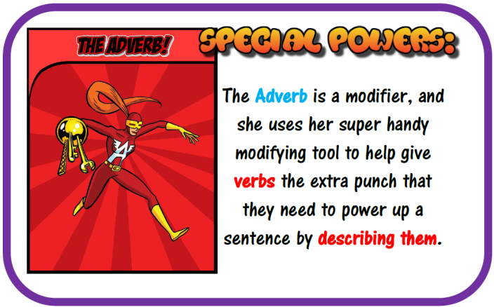

Remember that adverbs describe verbs (doing words). Adverbs usually end in –ly. They are area a really useful addition to your writing. They offer extra detail to verbs or adjectives helping create a picture in your mind when reading the sentence.

Think of five powerful adverbs that describe the verb shown in the picture.

ate

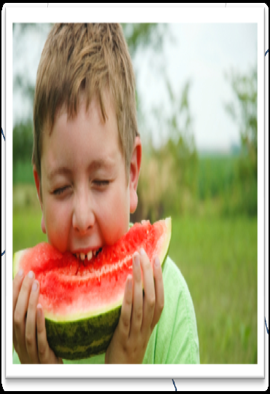

Add an adverb to each of the sentences below.

quickly happily innocently frantically cheerfully softly boldly

(think of your own adverbs or use the words in the box)

1. The angry teacher stormed _______________ into the classroom.
2. The horse ran__________________around the field.
3. The excited child skipped____________________ to the party
4. The huge giant stomped________________ around the town.
5. The excited boy ran _________________ after his friend.

Read the paragraph and circle all the adverbs.

Today I helped my Mum cook dinner. We carefully cut the vegetables and slowly placed them into a pan of boiling hot water. Next, Mum quickly browned the chicken in the frying pan and patiently let it cook through. I eagerly waited for my next job, which was to gently sprinkle the spices into the soup. However, I accidently poured in too much cumin. I quietly told Mum my mistake and she sweetly told me, as a child she had coincidently made the same mistake.

Review your learning

Write down what adverbs are in the box. No cheating!

How Confident are you with adverbs?

**🙂 😐 ☹️**

**TASK 4 – Prepositions**

***A preposition is a word that joins a noun to the rest of a sentence.***

***It explains where the noun is.***

*The bag was* ***on*** *the table.*

*The girl walked* ***under*** *the scaffolding.*

*It sat* ***among*** *the bushes.*

*The sentences would not work without the prepositions.*

**Common Prepositions**

about beneath into throughout

above beside near to

across between of toward

against by on under

among except onto up

at for out upon

behind from over with

below in through without

Add a prepositional phase to the end of these sentences to show where the events happened.

1. The boy climbed **over the fence**
2. The man was standing_______________________
3. The girl jumped____________________________
4. The dog ran_______________________________

**Complete the text with prepositions.**

Usually I’m not interested ____ comics but I am curious______what happens in the next episode of the comic I am reading.The heroine, Kelly is a private dectective who is worried______________the disappearance of people in her city. People are frightened__________going out after dark and Kelly gets tired_______this and decides to do something. She is walking alone in the park when two enormous dogs attack her.

Review your learning

Write down what prepositions are in the box. No cheating!

How Confident are you with prepositions?

**🙂 😐 ☹️**

**Task 5**

**Identifying sentence structures**

**Identify the sentence structure – is it simple, compound or complex?**

A simple sentence has **one** main subject and verb.

A complex sentence has **2 subjects and 2 verbs** in a subordinate and main clause.

A compound sentence has **two main clauses** that make sense on their own a subject and verb in each.

Did you know:

Using a variety of sentence structure in your writing will help create an impact!

1. Mr Simon loved to eat rice pudding after his main meal every day.
2. When it is cold, bears hibernate in a cave or large hole to survive the winter.
3. School starts at 8.50 and ends at 3.20 for key stage two.
4. Why is Paul wearing a black jumper in this heat with a coat as well?
5. Quietly on their tiptoes, the children crept down the long corridor.
6. Without water, humans cannot survive for more than a few days.

Using different colours, highlight the simple, complex and compound sentences in the following paragraph.

Tsunami Witness Account

At 7.30 that morning some felt vibrations, but nothing was really thought of it. By 10.30am the tsunamis hit our island of Olhuveli, Maldives. We had seconds to react; the wave was so powerful. Whizzing past me was bedroom furniture, TVs, and fridges. We had to fight for our lives. The experience was terrifying. I never thought we were going to get off the island alive. The whole island was destroyed. The devastation was immense. The fear, people screaming and blood everywhere, will stay with me for a long time. I lost everything but I am so grateful for my life. I have an overwhelming feeling of sadness that is constantly with me, and this is for the people that really have lost everything. I think about the islanders and what wonderful people they are. I have thought of going back there to help them try and rebuild their island. God bless them all.

Write a descriptive paragraph for this picture. Make sure you use all 3 sentence types. Think carefully about the effect you are creating.

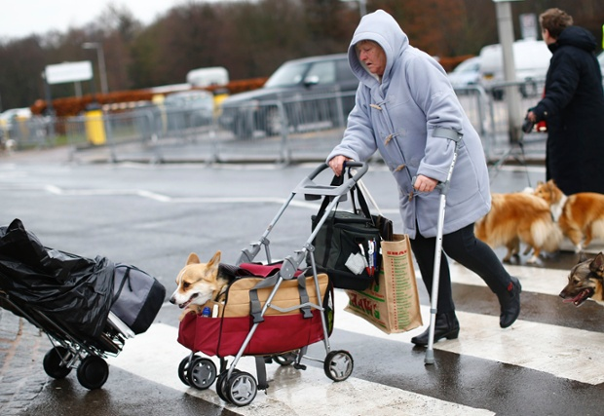

_________________________________________________________________________________________________________________________________________________________________________________________________________________________________________________________________________________________________________________________________________________________________________________________________________________________________________________________

Review your learning

Write down what a simple, complex and compound sentences are in the box. No cheating!

How Confident are you with sentence structure?

**🙂 😐 ☹️**

**Task 6**

**Conjunctions or connectives** are joining words. They connect phrases together into longer sentences to improve the flow of your writing.

**Here a few:**

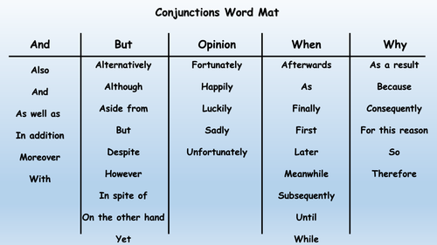

**The paragraph below is made up of only simple sentences. Re – write it using connectives to create complex sentences.**

Janet turned around. The noise behind her had startled her. She wanted to run away. She couldn’t. She took a deep breath. Carefully, she edged towards the door. Janet picked up a piece of wood from the floor. She didn’t know what was behind the door. The noise was getting louder. Janet was terrified. She kept walking forwards. Her hand touched the door handle. Her heart beat quickly. It was the only thing she could hear. Janet slowly opened the door. She didn’t want to see what was behind. She promised herself she’d never come back here again.

_____________________________________________________________________________________________________________________________________________________________________________________________________________________________________________________________________________________________________________________________________________________________________________________________________________________________________________________________________________________________________________________________________________________________________________________________________________________________________________________

Review your learning

Write down what a connective is and why we use them in sentences. No cheating!

How Confident are you with sentence structure?

**🙂 😐 ☹️**

**Task 7 Apostrophes of possession and apostrophe of omission.**

**Do you know the difference?**

**Possession**

To show that one thing owns another.

The lady’s hat.

*The lady owns the hat.*

**Omission**

Where you need to miss a letter out.

You’ve left some letters out.

*‘You have’ becomes ‘you’ve’.*

**Insert apostrophes into the sentences below:**

**1. My best friends sister is called Jodie.**

**2. I haven’t done my homework.**

**3. If they go to the shops theyll miss the football.**

**4. Frank Lampards goal this weekend was brilliant.**

**5. There wernt any eggs left after Jamie dropped the box.**

**6. Weve won lots of cups this year; were Coventrys best school.**

**7. Im always late for school in the morning, its my dads fault.**

**8. There arent many cars id like to drive but I do like BMWs.**

**9. I shouldve caught the 10.30 bus but I was late.**

**10. Patricks car isn’t very reliable, its always breaking down.**

Review your learning

Explain the rules of apostrophe of omission and apostrophe of possession. No cheating!

How Confident are you with apostrophes?

**🙂 😐 ☹️**

**Task 8 – Homophones**

**Homophones are words that sound the same but have a different meaning and spelling. They can be very confusing!**

**There are many homophones here are just a few:**

|  |
| --- |
| See the source image |
|  |
|  |
| If the wrong homophone is used a passage will be difficult to read, like the one below. However, if you do manage to read it aloud (allowed!), other people will be able to understand it perfectly.  Rewrite the passage below in you exercise book, with the correct homophone. There are 25 homophones to correct: |
| I maid my weigh down the rode. Suddenly eye sore a wight hoarse.  “Ware are ewe off two?” aye asked.  Too sea the see and watch the son go down.”  “Isle come with yew,” I said.  Sew, I court him and wee road together, wile the wind blue in hour hare.  ________________________________________________________________________________________________________________________________________________________________________________________________________________________________________________________________________________________________________________________________________________________________________________________________________________________________________________________________________________________________________________________________________________________________________________________________  Review your learning  Write down what homophones are. No cheating!    How Confident are you with homophones?  **🙂 😐 ☹️**  [Image result for whispers in the graveyard](https://www.bing.com/images/search?view=detailV2&ccid=pqOaEkXI&id=2D044BF105BFACFF261CF8BE1889954305B7B118&thid=OIP.pqOaEkXISMwA4kUe8R62cAHaLV&mediaurl=https://www.theresabreslin.co.uk/books/whispers2016-300.jpg&exph=459&expw=300&q=whispers+in+the+graveyard&simid=607994572729484687&selectedIndex=2)  **Task 9**  **Adjectives** are describing words they help make your writing more detailed and descriptive.  Read the paragraph below from Whispers in the Graveyard and highlight all the adjectives.  Despite his ailing health and lonely life style Mr Tate’s garden was always full of brightly coloured blooms, and the grass cut short with the hedgerow neatly trimmed. The clusters of yellow daffodils along the edge of the path could still be seen swaying gently on a dark winters nights that had now set in. It made Sol sad to think that he had never even had clean clothes, never mind a clean and tidy garden.  **Choose the adjectives from the box below or you can use your own to fill in the blanks. Make sure that the passage makes sense!**  She was a ________ _________ ________ hag with a moustache on her upper lip and a mouth as _________ as a ____________ gooseberry. Her apron was _______________ and ___________.  Her blouse had bits of breakfast all over it, toast crumbs and tea stains, as well as splotches of dried egg yolk. It was her hands, however, that disturbed us the most. They were_______. They were __________ with dirt and grime.  old disgusting brown long skinny transparent huge black small  sour green fine  greasy deep grey long dirty torn filthy stooped  See the source image  Write a paragraph to describe this picture. Try to include as many adjectives as you can!  Review your learning  Write down what adjectives are. No cheating!    How Confident are you with using adjectives in your writing?  **🙂 😐 ☹️**  See the source image**Task 10**  **Semi-colon and Colon**  :  ;  **What are they?**  A **semi colon;** can be used to replace a conjunction or full stop to connect two  sentences that are closely related to one another. This allows a connection to be  seen between the two sentences, whether they are similar or contrasting. They  can also be used in separated extended lists.  For example:  • “They love football; I can’t stand it.”  • “She asked if I was free; I was at another friend’s house sadly.”  • “For the cake, I need: eggs, but only free range; milk, preferably semi skimmed;  a new whisk (after I trod on mine) and sunflower oil.”  A **colon:** can be used to introduce an itemised list, or to isolate words or phrases to  create emphasis. In both situations, it allows us to see that something will follow of  importance. They can also introduce quotations.  For example:  • “Ingredients: eggs, flour, sugar, butter, milk, baking powder.  • “David Walliams has written a number of wonderful novels: ‘Grandpa’s Great  Escape, ‘Demon Dentist’ and ‘Ratburger’ to name a few.”  • “She knew what she was feeling: fear.”  • “I refer you to paragraph four: “we must show vigilance at all times”.”  **The following sentences are either missing punctuation, or only use full stops and**  **commas. Can you add colons or semi-colons where needed?**  1. The teachers were in favour of extra homework. The pupils, however, were not.  2.. England played their last four matches abroad against the following Argentina,  USA, Russia and Italy.  3. I nominate the following people for parts Anne, Bill and Fred.  4. The recipe needed bacon, smoked not unsmoked, risotto rice, which is also  labelled as arborio rice, stock cubes, preferably chicken but vegetable will do,  and spinach to serve.  5. It was intense, and all his stomach could feel was one thing butterflies.  6. Dickens has written many classics ‘Great Expectations’, ‘Oliver Twist’ and  ‘Nicholas Nickleby’.  Rewrite and correct the punctuation in the following paragraph?  I am here before you today as a human being, not as a lecturer or authority  figure. I need three things from you to be successful in this field of study,  caring, respect, trust and communication. As a great woman once said “we  can only do this if we are a united front”. Therefore I ask you to think, what  can we do for one another? I can support your education, you can push  yourself to your limits. Together, we can dream big, together, we can make it  big. All it takes is the following, blood, sweat, tears and love of your subject.  I want you to do you best, can you meet the challenge?  Review your learning  Write down what semi colons and colons are and when to use them. No cheating!    How Confident are you with using semi colons and colons in your writing?  **🙂 😐 ☹️**  See the source image  **Task 11**  Question Marks?  Question Marks are used when a question has been asked. Questions usually include the words, what, where, when, why, how, who, are, do, were, will, which and can.  Example:  What would you like for your lunch?  Where is your lunch box?  What time does lunch start?  See the source image |
| These sentences do not have any punctuation at the end. Either add in a question mark or an exclamation mark so each sentence has the correct punctuation:   1. What time does the film end 2. This is the best present ever 3. How dare you speak to me like that 4. How do spiders spin their webs 5. Sit down now 6. Why have you forgotten your PE kit 7. Someone help me 8. You made me jump 9. Do you know what bus to catch 10. Can I borrow a rubber 11. When I dyed my hair, it went green 12. I’ve won first prize   **Now complete this. Consider where the question marks and exclamation marks should go:**  **Check the text: Sea World Advert**  Ever wanted a day out the kids will always remember. Then come to sea world now. Our great activities will blow you away. It is fun for all the family and it is educational. Ever seen a real life Great White Shark. Then why not come visit our shark video room. We will watch a 3D video and take a look at a full sized great white shark. It is also chance to help save the shark from extinction by adopting a shark. All you do is sign and then pay £2 a month to help keep your shark safe. We will also send a photo of your shark.  Have you ever swam with seals. Well here is your chance. Come on our relaxing boat trip to see and swim with seals in their natural habitat. We promise the wonderful sights of seals will amaze you.  Review your learning  Write down how to use question marks and exclamation marks. No cheating!    How Confident are you with using question marks and exclamation marks in your writing?  **🙂 😐 ☹️** |
|  |
| Task 12  **Paragraphs**  A paragraph is a group of sentences about one main idea.  They break up long chunks of writing, making it clearer and more interesting for the reader.  They provide a clear structure and order to our writing.   * Start a new paragraph when you move to a new period of **time**. * Start a new paragraph when you move on to a new **topic** or subject. * **Talk**-start a new paragraph when you bring a new person into your writing, or when you change from one person to another (especially when writing conversation.)   **How to show a paragraph break:**  To clearly show where a new paragraph begins we have to indent the first line.      Notice that the first word is indented- it starts further in, leaving a gap so that the new paragraph is easily seen.    We left school at 7.30 in the morning to get to Paignton Zoo for 9 am. The teachers told us to take our bags with us…  OR  You should leave a line in between your paragraphs.  Whichever you choose, be consistent.!  **Re write the following account making sure you clearly show where the paragraphs should be.**  **Remember:**  **Time**  **Topic**  **Talk**  My Account of the school trip to the Zoo  We left school at 7.30 in the morning on a big old coach to get to Paignton Zoo for 9am. Whilst we were on the coach the teachers told us to take our bags with us and gave us our instructions for the day. When we finally arrived at the Zoo we were allowed to go and see the animals straight away. The first stop was the tiger’s cage. The tigers were huge and ferocious looking, the teachers would not let us stay there for long. Next, we went to see the snakes. The snakes were having a feed and were eating mice. The girls started screaming hysterically after watching the snake devour the mouse. Consequently teachers decided it was time to stop for lunch! A few hours later we went to see the elephants having a wash. This was the highlight of my day because the elephant shook water all over us- it was very funny. We got back to school late, we were all tired but happy. “This is my favourite school trip ever!” said my friend Jimmy. “Mine too’ I agreed. It really had been a fantastic day.  ________________________________________________________________________________________________________________________________________________________________________________________________________________________________________________________________________________________________________________________________________________________________________________________________________________________________________________________________________________________________________________________________________________________________________________________________________________________________________________________________________________________________________________________________________________________________________________________________________________________________________________________________________________________________________________________________________________________________________________________________________________________________________________________________________________________________________________________________________________________________________________________________________________________________________________________________________________________________________________________________________________________________________________________________________________________________________________________________________________________________________________________________________________________________________________________________________________________________________________________________________________________________________________________________________________________________________________________________________________________________________________________________________________________________________________________________________________________________________________________________________________________________________________________________________________________________________________________ |
| My Account of the school trip to the Zoo  We left school at 7.30 in the morning on a big old coach to get to Paignton Zoo for 9am. Whilst we were on the coach the teachers told us to take our bags with us and gave us our instructions for the day.  Change of time and place.  When we finally arrived at the Zoo we were allowed to go and see the animals straight away. The first stop was the tiger’s cage. The tigers were huge and ferocious looking, the teachers would not let us stay there for long.  Time  Next we went to see the snakes. The snakes were having a feed and were eating mice. The girls started screaming hysterically after watching the snakes devour the mice. Consequently the teachers decided it was time to stop for lunch!  A few hours later we went to see the elephants having a wash. This was the highlight of my day because the elephant shook water all over us- it was very funny.  Time  We got back to school late, we were all tired but happy.  Time  “This is my favourite school trip ever” said my friend Jimmy.  “Mine too” I agreed. It really had been a fantastic day. |
|  |
|  |

Time